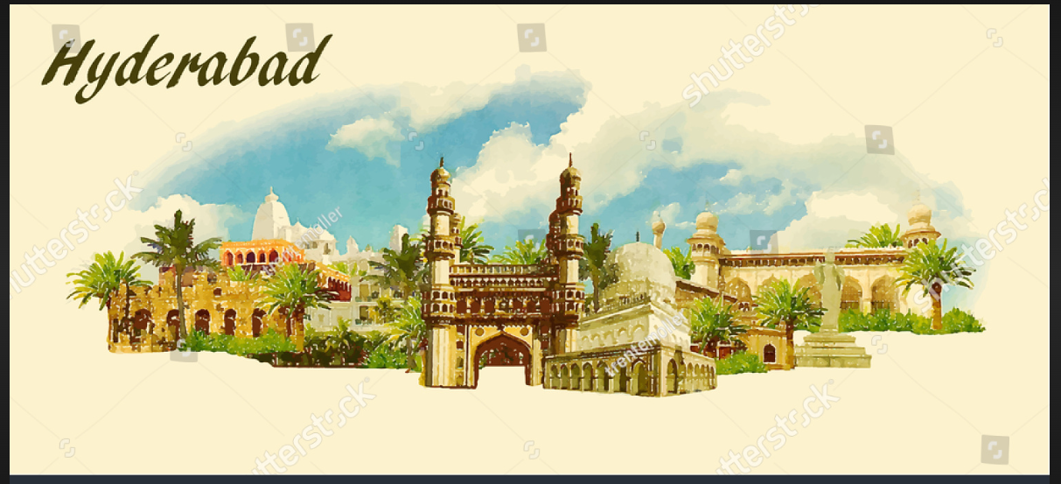

*NAME AYUSH A POLADIYA*

*ROLL NO :2317046*

*TOPIC: HYDERABAD TOUR ITINEARY*

*SUB : INDIAN KNOWLEDGE SYSTEM*

INDEX

|  |  |  |
| --- | --- | --- |
| SR.NO | TOPIC | PG.NO |
| 1. | INTRODUCTION | 3 |
| 2. | BREIF EXPLANATION ABOUT THE  ITINERARY | 4 |
| 3. | DETAILED ITINERARY | 5-10 |
| 4. | INFORMATION ABOUT THE PLACES MENTIONED | 11-19 |
| 5. | CONCLUSION | 20 |
| 6. | REFERENCES | 21 |

* INTRODUCTION OF INDIAN KNOWLEDGE SYSTEM

WHAT IS INDIAN KNOWLEDGE SYSTEM?

INDIAN KNOWLEDGE SYSTEM(IKS) is an innovative cell under the Ministry of Education (MOE) at AICTE, New Delhi. It is established to promote interdisciplinary research on all aspects of IKS, preserve and disseminate IKS for further research and societal applications.IT will actively engage for spreading the rich heritage of our country and traditional knowledge in the field of Arts and Literature, Agriculture, Basic Science, Engineering& Technology, Architecture, Management, Economics, etc.

ABOUT INDIAN KNOWLEDGE SYSTEM

The Indian traditional Knowledge Systems (Bhartiya Ganana Parampara) division of ministry of education (MoE) located at the headquarter of AICET, Delhi, was established as of October 20 and taken to be a part of the New Education Policy (NEP) starting 2023. e team initially consisted of Shri A.B. Shukla was the Chief Coordinator, followed by the teachers Dr. Sanjeev Panchal, Shri Anurag Deshpande and Shri Shreyas Khurekar. more professors who joined this noble research.

WHY ARE WE STUDYING IKS?

The main objective of drawing from our past and integrating the Indian Knowledge Systems is to learn that our ancient systems of knowledge represented by an unbroken tradition of knowledge mission and providing a unique perspective (Bhartiya Drishti) is used to solve the current merging challenges of India and the world.

* BRIEF EXPLANATION

Situated along the banks of the Musi River, Hyderabad is known as the city of Mughals and Nizams. The towering & spectacular architecture and monuments will force you to admire it. There are still many traditional and ancient markets in and around Hyderabad.

Hyderabad is one of the chief producers of natural pearls and is also a major contributor to the diamond trade, hence, it is referred to as the City of Pearls. With a height of 18 m and weight around 450 tons, this breathtaking statue of Buddha is his biggest single rock statue in the world. In this Trip we will be noticing about various traditional and cultural trends of Hyderabad and we will be witnessing a glimpse of local, monumental and cultural of the famous city Hyderabad.

We will go to various places such as: -

1. Ramoji film City.

2. Salarjung Museum.

3. Birla Temple.

4. Snow world.

5. Lumini Park.

6. Lazer show.

7. Hyderabad Zoo

8. Charminar and various other places.

* Detailed Itinerary: -
* Day 01: Mumbai to Hyderabad

- 09:50 PM: Meet our representative at CSMT Railway Station.

- Board Train: Board Train number 12701, Hussainsagar Express.

- Packed Breakfast Box: Provided for the journey.

- Overnight: Journey in Train.

Day 02: Hyderabad Arrival and Sightseeing

- 11:50 AM: Arrival in Hyderabad.

- 12:30 PM: Transfer to Hotel: Check-in and freshen-up.

- 1:30 PM: Lunch: Enjoy a delicious lunch.

1:30-4:00 Rest

- 5:00 PM: Afternoon Sightseeing:

- 3:30 PM: Lumbini Park: Explore the beautiful park.

- 4:30 PM: Laser Show: Experience the mesmerizing laser show.

- 5:30 PM: Birla Mandir: Visit the stunning temple.

- 7:00 PM: Evening: Return to the hotel.

- 8:00 PM: Dinner: Enjoy dinner at the hotel.

- Overnight Stay: Stay at the hotel.

* Day 03: Hyderabad Sightseeing

Breakfast:

Start the day with a hearty breakfast at 8:00 AM.

Morning Sightseeing:

- Salarjung Museum: Discover the rich collection of artifacts from 09:30 AM to 11:00 AM.

- Chaitanya Puri Jain Mandir: Visit the Jain temple from 11:30 AM to 1:00 PM.

Then spend sometime in temple and then we will travel to sonw world

Afternoon Activities:

- Snow World: Experience the thrill of snow activities from 4:00 PM to 5:30 PM.

- NTR Garden: Enjoy the serene atmosphere of the garden from 6:30 PM to 7:30 PM.

Return to Hotel: Back to the hotel by 8:30 PM.

Dinner: Have dinner at the hotel at 9:00 PM.

Overnight: Stay at the hotel.

* Day 04: Ramoji Film City Tour

Morning:

- 6:30 AM: Wake up early and freshen up.

- 7:30 AM: Enjoy a delicious local breakfast.

- 8:30 AM: Depart for Ramoji Film City, the world’s largest film complex.

Daytime:

- 10:30 AM - 5:00 PM: Spend the day exploring Ramoji Film Studio.

- 9:00 AM - 4:00 PM: Participate in adventure activities.

Evening:

- 5:30 PM: Return to the hotel in the evening.

- 7:00 PM: Have dinner at the hotel.

- 8:30 PM: Overnight stay at the hotel.

* Day 05: Hyderabad Sightseeing

Morning:

- 7:00 AM: After getting fresh, have breakfast at the hotel.

Daytime:

- 8:00 AM - 9:30 AM: Begin the city tour by visiting Navagraha Jain Derasar.

- 10:00 PM - 12:00 PM: Visit Nehru Zoological Park.

- 2:00 AM - 4:30 AM: Explore the Car Museum.

Evening:

- 5:30 PM - 7:00 PM: Free time for shopping (at own cost).

- 7:30 PM - 8:30 PM: Visit Charminar for sightseeing.

- 9:00 PM: Overnight stay at the hotel.

* Day 06: Departure Day

Morning:

- 9:00 AM - 10:30 AM: After breakfast, visit the local market.

- 10:30 AM - 12:00 PM: Purchase souvenirs for loved ones.

Afternoon:

- 12:30 PM - 1:30 PM: Enjoy lunch at a local restaurant.

Departure:

- 2:30 PM: Depart towards Hyderabad Railway Station.

- 3:30 PM: Catch Train no.12702 Hussainsagar Exp for the journey.

Tour Concludes:

Total Tour cost: 14000/- per person on Twin sharing basis.

* Inclusion:-

1. Twin sharing rooms.

2. All meals (Separate Kitchen ) & Mineral water.

3. Refreshments and food packets during tour.

4. Private AC bus (2x2) throughout the Journey.

5. Games and enjoyment.

6. Entry tickets at all places. (Ramoji, Parks, etc)

* Exclusion:

1. Any personal Expense.

2. Anything not mentioned above.

3. To and FRO train tickets

* INFORMATION OF THE PLACES MENTIONED: -
* BIRLA MANDIR:

Birla Mandir is a Hindu temple, The Birla’s built the Hyderabad temple in 1976 and constructed it with white marbles imported from Rajasthan. The hillock is at a height of 280-feet situated on a 13-acre plot. The construction took almost a decade to complete and was consecrated in the same year by Swami Ranganathananda of Ramakrishna Mission

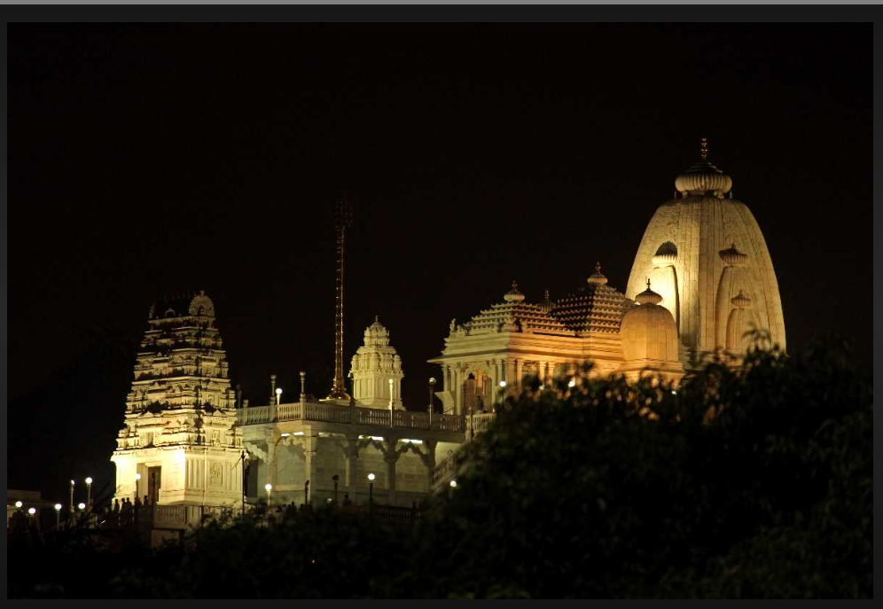

* LUMBINI PARK AND LASER SHOW

Lumbini Park is a major attraction on the Tank Bund Road [Hussain Sagar](https://hyderabadzone.com/attractions/hussain-sagar-lake-hyderabad.html) Lake. It was developed by the Hyderabad Urban Development Authority in the year of 1994 as a part of the Buddha Purnima Project which functions under the directives of the state government. The park is named after a garden where Siddhartha was born, who later becomes Gautham Buddha. In 2006, the park was renamed after the late Chief Minister Tanguturi Anjaiah as T. Anjaiah Lumbini Park, but it is still known by the name of Lumbini Park. Many of the excellent facilities available at the park include the musical fountain, laser show and water cascades and much more. Lumbini Park is considered as one beautiful park in Hyderabad city and a hot tourist site.The price for the laser show is 50 rupees per person

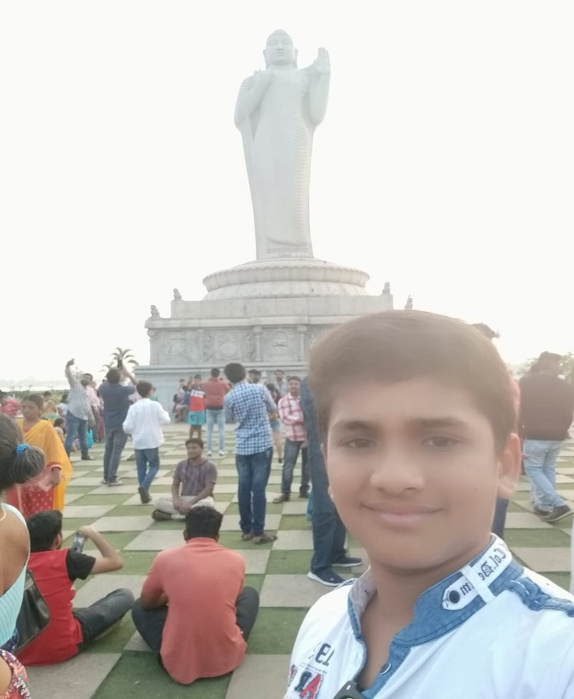

* SALAR JUNG MUSEUM

The Salar Jung Museum, situated in Hyderabad, Telangana, India, stands as one of the prominent National Museums in the country. Originally, it housed the private art collection of the Salar Jung family, eventually bequeathed to the nation following the demise of Salar Jung III in 1951, leading to its inauguration on 16 December of the same year. The museum boasts a diverse array of collections spanning various categories. The Indian Collection encompasses galleries dedicated to Indian Bronze, Textiles, Sculpture, Minor arts of South India, Miniature Paintings, Ivory Carvings, arms and armour, Metal Ware, and Jade Carving, showcasing the rich artistic heritage of the region. Noteworthy among these are Indian Miniature Paintings, Ivory Carving, and Jade Collection, each representing distinctive facets of Indian artistry. Additionally, the museum showcases Modern Paintings alongside Western and Eastern artworks. The Eastern section of the museum houses Japanese artworks, porcelain pieces, samurai swords, and sculptures from China, Japan, Tibet, and Burma, offering a glimpse into the diverse cultural and artistic traditions of the East. The museum also features collections of Qurans and clocks, adding further depth to its eclectic offerings.

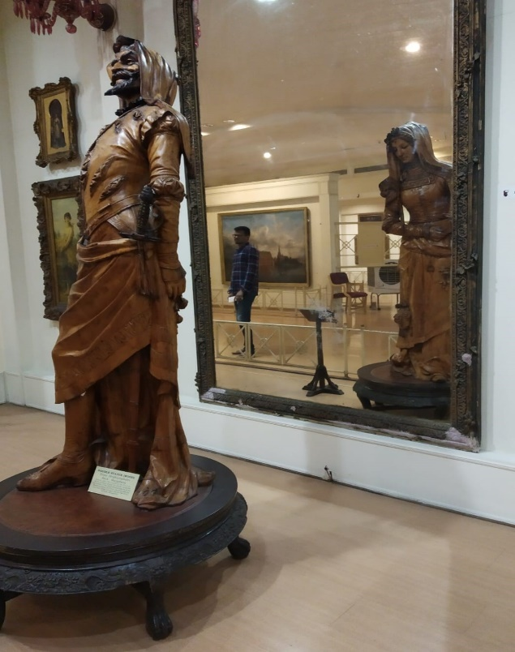

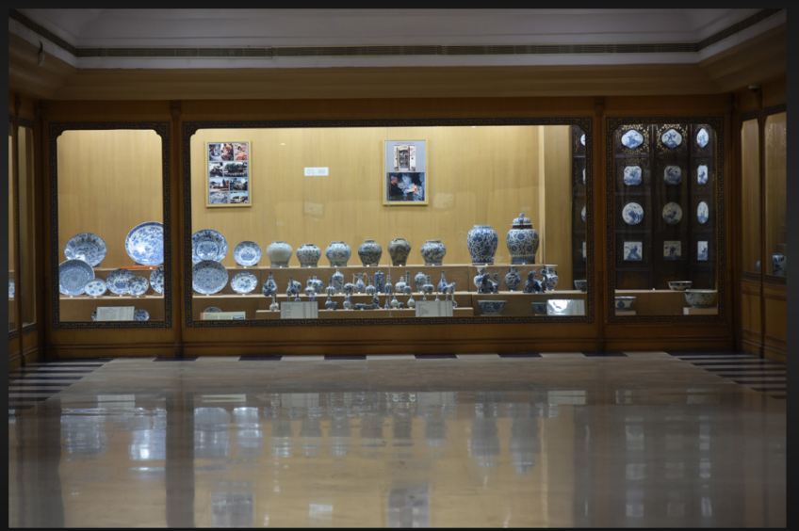

* CHAITANYA PURI JAIN MANDIR:

IT’S a JAIN Mandir which is built by white marble, surrounded by Garden

With Beautiful Scenery.

* NTR GARDEN:

NTR Gardens is a small public, urban park of 36 acres adjacent to Hussain Sagar lake in Hyderabad, India. It is named after the former Chief minister of Andhra Pradesh, N. T. Rama Rao. Constructed in several phases since 1999, the area that is predominantly a park is geographically located in the center of the city, and is close to other tourist attractions such as Birla Mandir, Necklace Road and Lumbini Park. It is maintained by the Buddha Purnima Project Authority that functions under the directives of the Government of Telang

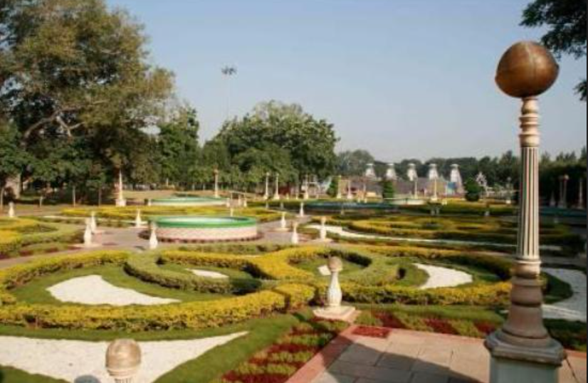

* KULPAKJI JAIN TEMPLE

Kulpakji also Kolanupaka Temple is a 2,000-year-old Jain temple at the village of Kolanupaka in Aler City, Yadadri district, Telangana, India. The temple houses three deities: one each of Lord Rishabhanatha, Lord Neminatha, and Lord Mahavira. The image of Lord Rishabhanatha, carved of a green stone has been historically famous as "Manikyaswami" and Jivantasvami.

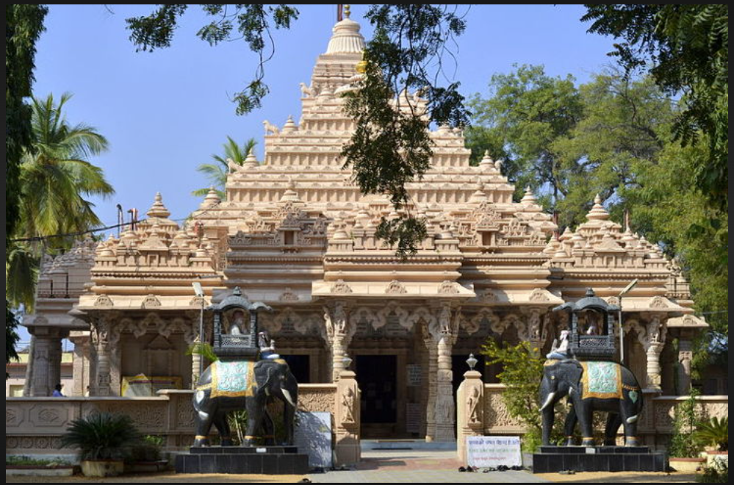

* NEHRU ZOOLOGICAL PARK

Nehru Zoological Park is one of the largest zoos of India and one of the top sightseeing places to visit in Hyderabad. Run by the Forest department, Government of Telangana, the zoo has been named after Jawaharlal Nehru, the first prime minister of the country. Spread over an area of approximately 380 acres, the Nehru Zoo Park boasts of almost 1,500 species of birds, mammals and reptiles. Adding to the extensive varieties of wildlife, this zoo park is considered to be the first one where animals are kept.

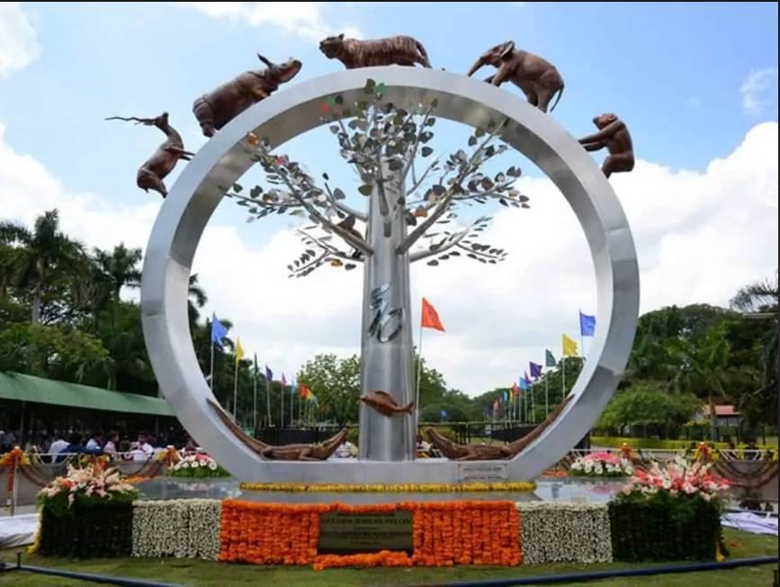

* RAMOJI FLIM CITY:

Ramoji Film City is an integrated film studio facility located in Abdullahpurmet, Hyderabad, India. Spread over 1,666 acres it is the largest film studio complex in the world and as such has been certified by the Guinness World Records. It was established by Telugu media tycoon Ramoji Rao in 1996. The Guardian described Ramoji Film City as "city within a city."

It is also a thematic holiday destination and a popular tourism and recreation center, containing natural and artificial attractions including an amusement park. Around 1.5 million tourists visit the place every year.

People can visit the film sets, theme parks, amusement rides, etc. The film city also has the set used for the films Bahubali: The Beginning (2015) and Baahubali 2: The Conclusion (2017); all the statues and props used in the films can be seen here. Around 1.5 million tourists visit the place every year.

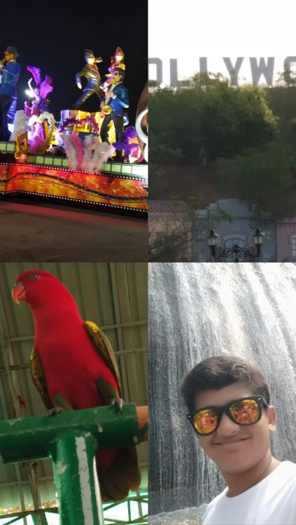There are various film shooting done here. They provide bus for travelling around the film city. There are various hotel inside the film city .

* SUDHA CARS MUSEUM:

Sudha Cars Museum is a place in Hyderabad, India, where you can see unique cars that look like everyday objects. A man named Kanyaboyina Sudhakar started making these cars as a hobby when he was in school. He opened the museum in 2010. Sudhakar Yadav has always liked cars and making things. He made his first car when he was only 14 years old, using parts he found in junkyards. He even got into the Guinness World Records in 2005 for making the largest tricycle. The museum is mentioned in the Limca Book of Records and has been on Ripley's Believe It or Not.

Each car in the museum has a sign that tells you about the car, how long it took to make, and how fast it can go. The museum also has the world's smallest double decker bus, which can fit 10 people. There are 12 small motorcycles on display, with the smallest one being only 33 centimeters long.

Sudhakar Yadav makes special cars for different events. For Women's Day, he made a car shaped like a handbag. For Children's Day, he made cars that look like a pen, pencil, and sharpener. Making these homemade cars costs between ₹85,000 to ₹150,000, but they are not for sale. Sometimes the cars are taken out of the museum for shows where people can see them being driven.

If you want to visit the Sudha Cars Museum, the entry fee is ₹100 for adults, ₹80 for children, and ₹100 if you want to use your mobile phone or camera inside.

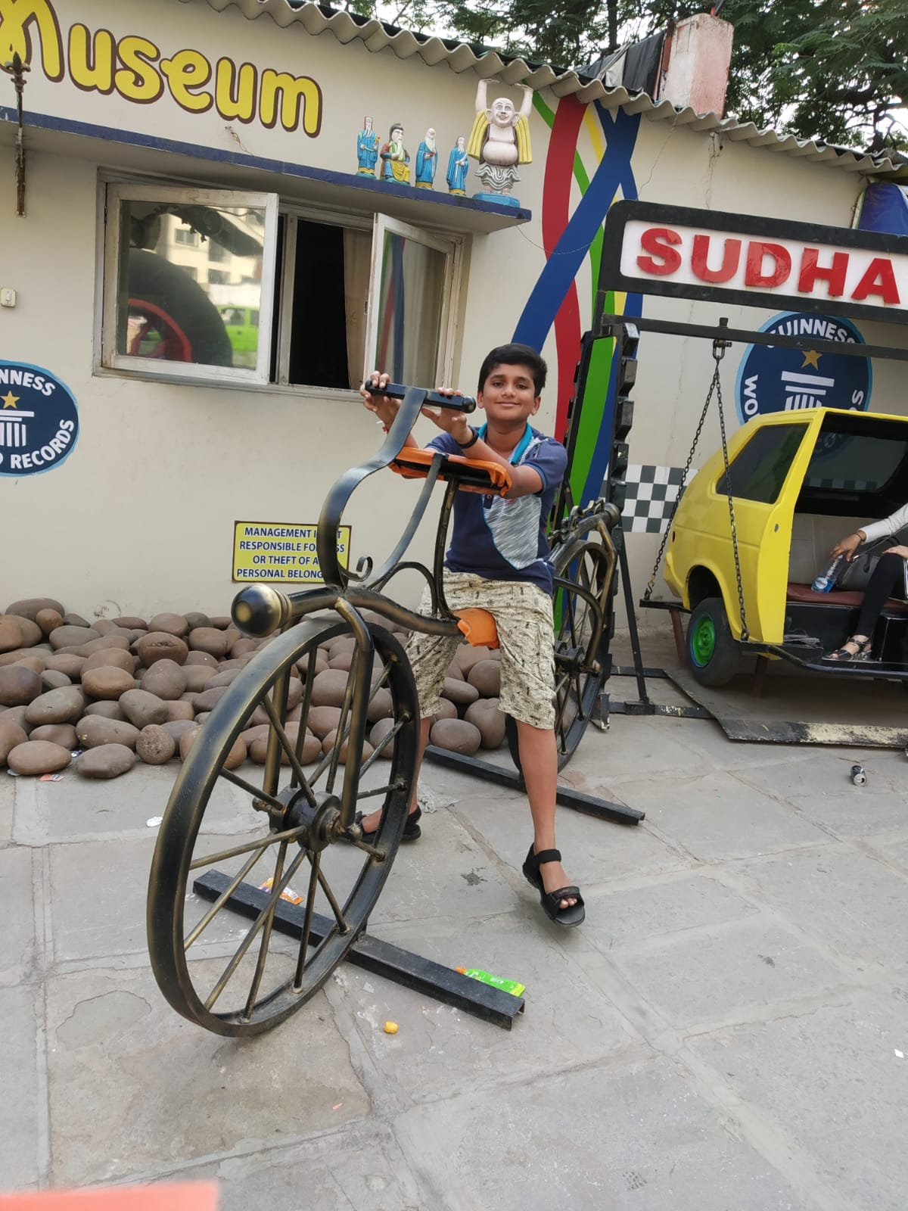

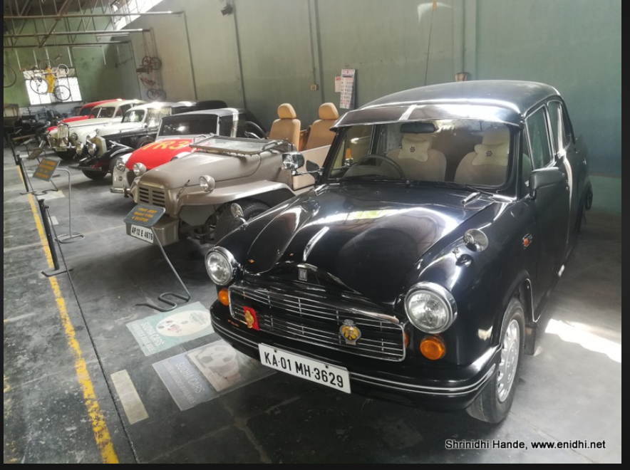

* CHARMINAR

The Charminar is a famous monument in Hyderabad, India, built in 1591. It's a symbol of the city and is even on the emblem of Telangana. The Charminar has a mosque on its top floor, which has been there for over 425 years. Besides its historical and religious importance, it's also known for the busy markets around it and is a top spot for tourists in Hyderabad. Many festivals, like Eid al-Fitr, are celebrated there because it's close to the main mosque, the Makkah Masjid.

The Charminar sits on the east side of the Musi River. To the west is the Laad Bazaar, and to the southwest is the beautifully decorated Makkah Masjid.

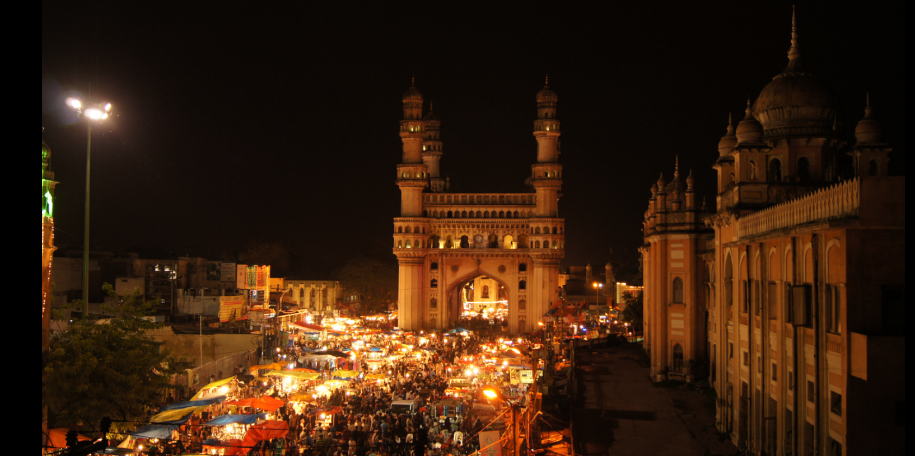

* CONCLUSION

In conclusion, Hyderabad stands as a vibrant city that seamlessly blends its rich cultural heritage with modernity. Its historical monuments, flavorful cuisine, and booming IT industry make it a city of contrasts and opportunities. And it has very beautiful and famous places to visit such as Charminar ,Ramoji Flim city,NTR garden,Nehru zoological park etc. Traditional places like Chaitanyapuri Jain Mandir, Kulpakhjii Jain Mandir and Birla Mandir etc. If you want to spend time with family and enjoy your vacation Hyderabad is a must visit place for everyone can go and enjoy your vacation in Hyderabad.

* REFERENCES

<https://jainsite.com/categories/jain-temple-in-hyderabad/>

<https://salarjungmuseum.in/explore-museum.html>

<https://www.ramojifilmcity.com/>

<https://hyderabad.telangana.gov.in/tourist-place/hussain-sagar-lake/>

<https://www.hyderabadtourism.travel/sudha-cars-museum-hyderabad>

JAINAM TOURS AND TRAVELS